**TABLE OF CONTENTS**

**ABSTRACT…………………………………………………………………………. 1**

**CHAPTER**

**I INTRODUCTION**

Project Context**……………………………………………… 2**

Purpose & Description**……………………………………... 4**

Objectives**…………………………………………………… 4**

General Objectives**………………………………………….. 5**

Specific Objectives**………………………………………….. 5**

Scope & Limitations **………………………………………… 5**

Scope **……………………………………………………….. 5**

Limitations**…………………………………………………… 6**

Statement of the Hypothesis**………………………………. 6**

Definition of Terms**………………………………………….. 7**

**II REVIEW OF RELATED LITERATURE…………………………… 8**

**III TECHNICAL BACKGROUND……………………………………. 11**

Developing Tools**…………………………………………… 11**

Details of Technology Used**……………………………… 12**

Conceptual Framework**…………………………………… 13**

Figure 3.1 : Paradigm of the

Propose Study**……………………………… 13**

**IV METHODOLOGY**

Research Design**…………………………………………… 14**

Research Environment and Participants**………………… 15**

Table 4.1. Respondents Profile**…………………. 15**

Research Instruments**…………………………………… 16**

Questionnaire**……………………………………………. 16** Methods Used in Developing the System**……………… 16**

Figure 4.1**………………………………………….. 17**

System and Software**…………………………………… 17**

System Design**…………………………………………… 18**

Implementation**…………………………………………… 18**

Testing**……………………………………………………… 18**

Deployment of the System **………………………………. 19**

Use Case Table**…………………………………………… 19**

Table 4.2 : Use Case Scenario**………………….. 19**

Table 4.3 : Story Mode**……………………………. 20**

Table 4.4 : Puzzle Mode**………………………….. 20**

Table 4.5 : Take Survey**…………………………. 21**

Table 4.6 : Exit Game**……………………………… 21**

Table 4.7 : View Story**…………………………….. 21**

Table 4.8 : New Game**…………………………….. 22**

Table 4.9 : Resume Game**………………………… 22**

Table 4.10 : Stage Level**………………………….... 23**

Table 4.11 : Show Controls**………………………… 23**

Table 4.12 : Change Music Volume**……………… 24**

Table 4.13 : Change SFX Volume**……………….. 24**

Table 4.14 : Change Look Sensitivity**…………... 24**

Data Flow Diagram**……………………………………….. 25**

Figure 4.2 :Flowchart of the

Propose System 1**…………………………**  **26**

Figure 4.2 :Flowchart of the

Propose System 2**…………………………**  **27**

Statistical Treatment Data**……………………………….. 28**

**V RESULTS AND DISCUSSION**

Results**…………………………………………………….. 29**

Table 5.1 : Test Performance of the

Grade 6 Pupils**…………………………….. 29**

User-Guide**………………………………………………… 31**

Figure 5.1 : Main Menu**…………………………… 32**

Figure 5.2 : Settings**……………………………… 33**

Figure 5.3 : Controls**………………………………. 33**

Figure 5.4 : Story Mode Menu 1**…………………. 34**

Figure 5.5 : Story Mode Menu 2**…………………. 35**

Figure 5.6 : Story Mode Cutscene**……………… 35**

Figure 5.7 : Story Mode**…………………………. 33**

Figure 5.8 : Puzzle Mode**………………………. 33**

Figure 5.9 : Puzzle Mode Menu**………………… 38**

Figure 5.10 : Pause Menu**……………………… 38**

Figure 5.11 : Exit Confirmation Menu**…………….** **39**

Figure 5.12 : Game Website**……………………** **39**

Figure 5.13 : Select Stage**………………………** **40**

**VI CONCLUSION AND RECOMMENDATION**

Summary**…………………………………………..……..** **41**

Conclusions**…………………………………………..….** **42**

Recommendations**………………………………………** **42**

User’s Guide**…………………………………………..…** **44**

**APPENDICES**

Appendix A Transmittal Letter**…………………………………… 48**

Appendix B Questionnaire**………………………………………… 49**

Appendix C Narration of the Story**……………………………….. 52**

Appendix D Sample Code**……………………………………….. 58**

Appendix E Picture Documentation**…………………………….. 59**

**CURRICULUM VITAE**

Lord Son V. Pabriga**……………………………………………….. 61**

R.A. Patricia C. Corage**………………………………………….. 62**

Glenn Gerald F. Dapitilla**………………………………………… 63**

Melchizedek A. Cruel**…………………………………………….. 64**

Bryle Anthony M. Orevillo**………………………………………… 65**

**REFERENCES………………………………..…………………………… 66**

**LIST OF TABLES**

Table 4.1. Respondents Profile**…………………………………… 15**

Table 4.2 : Use Case Scenario**…………………………………… 19**

Table 4.3 : Story Mode**………………………………………… 20**

Table 4.4 : Puzzle Mode**………………………………………… 20**

Table 4.5 : Take Survey**………………………………………… 21**

Table 4.6 : Exit Game**………………………………………… 21**

Table 4.7 : View Story**………………………………………… 21**

Table 4.8 : New Game**………………………………………… 22**

Table 4.9 : Resume Game**………………………………………… 22**

Table 4.10 : Stage Level**………………………………………… 23**

Table 4.11 : Show Controls**………………………………………… 23**

Table 4.12 : Change Music Volume**……………………………… 24**

Table 4.13 : Change SFX Volume**……………………………… 24**

Table 4.14 : Change Look Sensitivity**……………………………… 24**

Table 5.1 : Test Performance of the Grade 6 Pupils**…………… 29**

**LIST OF FIGURES**

Figure 3.1 : Paradigm of the Propose Study**……………………… 13**

Figure 4.1**…………………………………………………………… 17**

Figure 4.2 :Flowchart of the Propose System 1**…………………** **26**

Figure 4.2 :Flowchart of the Propose System 2**…………………**  **27**

Figure 5.1 : Main Menu**……………………………………………… 32**

Figure 5.2 : Settings**……………………………………………… 33**

Figure 5.3 : Controls**……………………………………………… 33**

Figure 5.4 : Story Mode Menu 1**…………………………………… 34**

Figure 5.5 : Story Mode Menu 2**…………………………………… 35**

Figure 5.6 : Story Mode Cutscene**……………………………… 35**

Figure 5.7 : Story Mode**………………………………………… 33**

Figure 5.8 : Puzzle Mode**……………………………………… 33**

Figure 5.9 : Puzzle Mode Menu**………………………………… 38**

Figure 5.10 : Pause Menu**……………………………………… 38**

Figure 5.11 : Exit Confirmation Menu**……………………………** **39**

Figure 5.12 : Game Website**……………………………………** **39**

Figure 5.13 : Select Stage**……………………………………** **40**

**ABSTRACT**

It remains unknown to numerous Filipinos especially on the pupils the noble effort of Dagohoy on how he serves the nation. Incorporating it into the lesson plan isn't serving enough to leave a mark on pupils, like other revolutionaries, due to the lack of ways to narrate it to the class effectively. Hence, intertwining it to something modern can be an efficient way for individuals to know the story of Dagohoy such as using the Dagohoy’s Revolt 3D Educational Game Application which may help learners to have a knowledge about it.

This research was conducted to determine the effectiveness of Non-Gamification method and Gamification method (Dagohoy’s Revolt 3D Educational Game Application) in understanding the story of Dagohoy’s Revolution on the Grade 6 pupils of Mater Dei Laboratory Elementary School. The study used experimental research. There were two sections being tested using the said two methods. Both sections were comprised of 15 pupils. Based on the test results, there was a significant difference between the performance of the pupils, Gamification method was more effective compared to the Non-Gamification method because pupils can manifest and comprehend the happenings of the story since there were scenes that being showed on the game application

**Chapter I**

This chapter presents an overview of the project study conducted by the researchers, the problems defined, the purpose of the study, the objective of the study, the significance of the study, the scope and limitations, and the definition of terms used.

**Project Context**

Educational games are innovative and modern ways to encourage learners to accumulate needed knowledge they have difficulty mastering. It stimulates the users minds extensively while having fun. Also, it serves as a channel to deliver a specific topic without any burden due to the fun factor.

The Educational game will be delivered in a three-dimensional form to encourage a larger group of users that can benefit from the game itself. The way the game built was modernized, which can successfully cater to the 21st century learners as it will not bore them. And applying educational game in History to pupils will significantly expand influence on their ability to communicate and comprehend in the world where things are difficult to fathom.

History is a narration of the events which have happened among mankind, including an account of the rise and fall of nations, as well as of other great changes which have affected the political and social condition of the human race (Anderson J.J, 2019). Studying history will help the pupils to observe and understand how people and societies behave. **Also, it helps to provide people with a sense of identity.**

The researcher examines all of the historical events about the Revolt of Francisco Dagohoy. Narrating it through a three-dimensional educational game with a novel user interface is believed to be an efficient way of re-telling his noble ways of protecting the nation, which is significant to give honor.

Dagohoy’s Revolt 3D Educational game application is created to educate the users and set a reminder that learning can be done entertainingly. Dagohoy's revolt is a necessary part of history that should be continuously passed onto the next generation to remind the importance of fighting back against oppression.

**Purpose**

The purpose of the project is to create a user-friendly and effective application that will allow pupils to easily and quickly access the information that will be used to evaluate the pupils' understanding of historical events. As an additional feature, it will provide the pupils with exciting and engaging ways to learn about Dagohoy's Revolt while also helping them gain a greater understanding of the subject. Furthermore, this project provides a different approach in teaching Dagohoy's Revolt to every pupil throughout the new normal educational system of this school year by using alternative approaches through the use of Android-based applications.

Therefore, the researchers aim to enhance pupil's awareness using a Dagohoy’s Revolt 3D Educational Game Application while making it entertaining for the pupils to study.

**Objectives**

The objective of the propose study is to solve the given problems wherein pupils find difficulty in learning and understanding history of Dagohoy’s Revolt. With the propose study, learning history will be more fun and easier for the pupils who will use it.

**General Objectives:**

The main objective of this project is to design and develop a Dagohoy’s Revolt 3D Educational game application for the Grade 6 Elementary Pupils while aiming to provide a convenient way for the pupils to learn Dagohoy’s Revolt history.

**Specific Objective:**

* To create a game that will have a campaign/story mode that tells the story of Francisco Dagohoy’s Revolt.
* To create a game playable for Android phones and Windows PC.
* To provide a game that can be played offline.
* To provide an entertaining way to learn
* To reduce the time and effort involved in studying Dagohoy’s Revolt
* To provide Dagohoy’s Revolt history
* To provide a website that contains the download page and trailer of the game.

**Scope and Limitations**

**Scope:**

The project is 3D-RPG Educational Game about Dagohoy's Revolt, developed using Unity game engine. The project has a campaign/story mode that narrates the story

of Dagohoy's Revolts. The game can be downloaded and installed on Play Store and Windows PC. This application is developed for easy learning and knowing about Dagohoy's Revolt and be played by the pupils' desire anytime. Moreover, the system has a quiz game for the pupils to enhance vocabulary skills about Dagohoy's Revolt. The study is intended for all ages who want to learn from it to enhance the knowledge in the Revolt of Francisco Dagohoy.

**Limitation**

The proposed study is limited to learning Dagohoy's Revolt only. Also, this is limited to teaching the historical revolt of Dagohoy and cannot go beyond topics like the childhood life of Francisco Dagohoy. The game will not be available on Steam and App Store due to some financial requirements. This game is also not available for IOS devices. In story mode, the story only narrates on what happened, with no dialogue between the characters in order to keep the story concise and avoid unfounded opinions.

**Statement of the Hypothesis**

The study aimed to test the null hypothesis that there was no significant difference between the Gamification and Non-Gamification on the performance of the Grade 6 pupils of Mater Dei Laboratory Elementary School between the test results.

**DEFINITION OF TERMS**

**3D** – Three Dimensional

**RPG** – Role Playing Game

**Steam** – A desktop application for downloading games

**Play Store** – An android application for downloading games and application

**App Store** – An IOs application for downloading games and application

**Android** – a mobile operating system (OS)

**Hardware** – refers to the physical parts of a computer and related devices.

**Platform** – often used when referring to what kind of computer systems a certain software program will run on.

**Developer** – makes software for the world to use

**Chapter II**

**Review of Related Literature**

The following studies were conducted by the researchers and the result were used as the basis to support the given study, “Dagohoy’s Revolt 3D Educational Game Application for Elementary Pupils”.

“Abakada” is often referred to as the Tagalog Abakada or the Filipino Alphabet. This alphabet app was created and evaluated by educators to assist youngsters in memorizing the letters of the Filipino alphabet. Children enjoy themselves while learning with the Filipino Alphabet app. This Alphabet software is geared at preschool, between the ages of two and five. The ABC game was designed to teach youngsters the Filipino alphabet, particularly those who are not native speakers of the language but are interested in learning it. Abakada is critical for children’s development of expressive and receptive language abilities and their acquisition of new Tagalog vocabulary and understanding.

The following study is similar to the proposed study of the researchers, it can be intended for educational purposes and involves the use of Android applications to attain this. The only difference between them is that the application system does not use a third-dimensional (3D) engine, and the topic material that will be learned is not historical.

“Maddie and Matt's Happy Earth”, Pinoy Developers developed educational apps such as Maddie and Matt's Happy Earth. An A to Z's of Good Manners and Values developed by AppLabs Digital Studios Inc (ADSI) and KidApps Inc. (KIA) are among the first educational apps that can enrich Filipino minds children significantly. Maddie and Matt's A to Z of Appropriate Behaviour and Values is also available in Tagalog (Ang A-Z ng Kabutihang Asal at Kagandahang Ugali nina Maddie at Matt). It is helpful to teach pupils on their mother tongue or indigenous language before they learn any other language.

As with previous studies, it supported the researcher’s proposed study, both studies show that learning may also be fun. By the use of the application, it would develop pupils' knowledge. Video games are quite popular right now due to its convenience. The proposed study is a video game as well, this literature strengthens the study.

“Tagalog Toddler” is a one-stop shop for children's entertainment. It has a variety of engaging and enjoyable instructional activities for toddlers and even preschoolers. It is a proudly Filipino-made software that children will appreciate. This Filipino software features an animated character, an animated voice-over, and noises that are all geared to encourage children to begin learning even if they are not yet in school. It is a never-ending game designed for toddlers. Additionally, it is an excellent tool for learning Tagalog vocabulary.

This research is comparable to the proposed study in that they both feature the notion of using animated characters, lively voice overs, and noises to make the experience more enjoyable for the youngsters participating in it.

"SEED" is a second commercial endeavor and the first immersive 3D world by Digital Future Lab. The game was developed in 2016, and its commercial release is in 2021. It is an adventure-puzzle game set in a world on the brick of environmental collapse: a symbolic journey encouraging players to visualize themselves as agents of positive change. SEED gameplay is a twist on the tower defense genre. Instead of asking players to prevent enemies from reaching the end of a path, SEED asks players to help gentle creatures navigate increasingly challenging paths. The gameplay montage is from the game as shown at Geek Girl Con 2018 in Seattle.

The following study is similar to the proposed research of the researchers; the game was designed using Unity 3D engine. It can be used as a research tool and professional development opportunity for hundreds of students.

Playing video games is now possible everywhere and at any time in a technologically advanced environment equipped with laptop computers, smart phones, game consoles (both mobile and stationary), set-top boxes, and several other digital devices. It is hoped that the natural drive that young people have for games may be merged with educational material and objectives to create what Prensky refers to as "digital game-based learning" as a result of this phenomena.

**Chapter III**

**Technical Background**

This chapter discussed the project's technicality by which it described the type of project to be developed and its functionality.

**Developing Tools:**

Hardware:

For smartphone:

Android 8 and above

For laptops and computers:

At least Intel Core i3 processor

At least 4GB RAM

At least 2ghz CPU

Software:

Operating System:

Recommended (Windows) at least a version of 10 and above.

**Details of Technology Used**

This chapter discusses the technologies to be used in developing and implementing the project.

* **Unity -** is a cross-platform game engine that is developed by Unity Technologies. This is widely used by companies and indie game developers.
* **C# -** is the programming language that will be used in this project is C# because this is the default language that unity supports.
* **Visual Studio Code -** is a source-code editor made by Microsoft. This will be used as an external code editor for unity to make programming faster because the default code editor in unity is just a plain text editor and does not have intellisense.
* **Blender** - is a free and open source 3D creation suite. It supports modeling, rigging and animation which is perfect for what 3D game needs.
* **Adobe Photoshop -** is raster graphics editor developed and published by Adobe Inc. This application will be used to create textures like normal map and height map for the materials in the game.
* **Adobe Illustrator -** is a vector graphics editor developed and marketed by Adobe Inc. This application will be used to crate graphical assets for the game like buttons and other elements that will appear in the UI (User Interface) of the game.
* **Vue.js – is** an open-source front end JavaScript framework for building user interfaces and single-page applications. This will be used to create the game’s website.

**Conceptual Framework of the Propose Study**

The conceptual framework of the proposed study consists of three parts, Input, Process, and Output. The Input column includes all software and hardware and the sources of information where the researchers gathered data and the other types of research used in the study. In the Process, the column includes the phases in creating the proposed system. Lastly, the Output of the said process is the proposed study “A 3D Educational Game Application for Elementary Pupils”.

INPUT

OUTPUT

PROCESS

“A 3D Educational Game for Elementary Pupils”

Identify the problems that were encountered in the existing system.

Interpret data Gathered.

Design and Develop the proposed system

Test and Debug the system

Implementing the proposed system.

References

Related Information:

Thesis Books

Library

Internet

Instruments:

Questionnaire

Methods used:

Descriptive

Research

System Requirements:

Windows OS

Android OS

Android Development tools

Feedback

**Figure 3.1: Paradigm of the Propose Study**

**Chapter IV**

**Methodology**

This chapter presents the research design, methods and the instruments that the researchers used in conducting the research. Thus, the researchers will consider the techniques and procedures in order to achieve the goal of the study.

**Research Design**

The researchers utilized an experimental research to determine the effectiveness of Non-Gamification and Gamification method (Dagohoy Revolt: 3D Educational Game Application) in understanding the history Dagohoy’s Revolution of the Grade 6 pupils in Mater Dei Laboratory Elementary School. The performance shown in the test results of the respondents as the basis in determining the methods. The researchers conducted the study in two groups. The first group used the Non-Gamification and the other group used the Gamification method. Both groups took the same test which was facilitated by the researchers.

**Research Environment and Participants**

The locale of the study was Mater Dei Laboratory Elementary School. Mater Dei Laboratory Elementary School, situated in Cabulijan, Tubigon, Bohol. The school is approximately 1,800 meters away from the town proper of Tubigon. It has 11 teachers and 1 principal. Their physical facilities have 11 classrooms, 1 library, and 1 canteen.

The researchers chose the school because it was convenient for the researchers and a well-established provider of online classes.

Table 4.1. Respondents Profile

|  |  |  |  |
| --- | --- | --- | --- |
| Respondents | No. of Pupils Enrolled | No. of Pupils Respondents | Percentage % (Respondents) |
| Section 1 | 24 | 15 | 30.6% |
| Section 2 | 25 | 15 | 47% |
| Total Respondents | 49 | 30 | 77.6% |

The Grade 6 pupils have two sections; namely, Section 1 and Section 2. Section 1 was composed of 24 pupils and Section 2 composed of 25 pupils.

**Research Instrument**

**Questionnaires**

The researchers prepared a same questionnaire for both sections of Grade 6 pupils of Mater Dei Laboratory Elementary School. The questionnaire was composed of 15-item of multiple choice with four choices.

The only difference was that, the Grade 6 pupils Section 2 have the opportunity to play the Beta application of Dagohoy’s Revolt game app.

The researchers used this method so that the researchers can form a corroborated conclusion about the two variables performed over some time.

**Methods Used in Developing the System**

The researchers used the waterfall model in developing the system application "Dagohoy's Revolt." The waterfall model is a sequential design process that is used in software development. It describes progress as constantly falling (like a cascade) through the phases of conception, initiation, analysis, design, construction, testing, production/implementation, and maintenance.

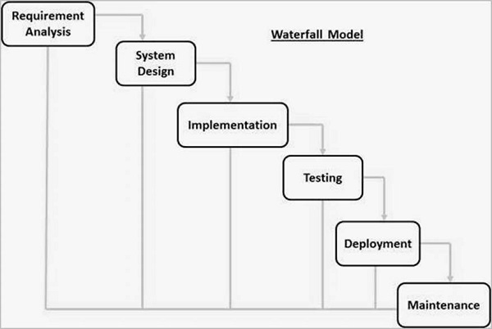

**Figure 4.1**

**System and Software**

All possible requirements of the system to be developed were captured in this phase and documented in a requirements specification document. In this phase, the researchers gathered the data and requirements in building or developing the system. In this phase also, the researchers started the documentation for the system proper.

**System Design**

The requirement specification from first phase were studied in this phase and system design was prepared. System Design helps in specifying hardware and system requirements. It also helps in defining the overall system architechture. In this phase, the researchers developed the system starting with the designing of the system and the system architechture and other diargrams to see the desired outcome of the system.

**Implementation**

With inputs from the system design, the system was first developed in program units, which were integrated in the next phase. Each unit was developed and tested for its functionality which is reffered to as Unit testing. In this phase, the researchers were ready to create prototypes for preliminary testing.

**Testing**

All the units developed in the implementation phase were integrated into a system after the testing of each unit. In post integration, the entire system was tested for any faults and failures.

**Deployment of the System**

Once the functional and non-functional testing done, the product is deployed in the customer environment or released into the market. The deployment of the system was in Mater Dei Laboratory Elementary School which took part in the study.

**USE CASE**

Table 4.2 : Use Case Scenario

|  |  |  |  |
| --- | --- | --- | --- |
| Level-0 | Level-1 | Level-2 | Level-3 |
| Game (Dagohoy's Revolt) | Launch Game | Story Mode | View Story |
| Puzzle Mode |  |
| Take Survey |  |
| New Game |  |
| Stage Select |  |
| Exit Game |  |
| Resume Game |  |
| Settings | Change Music volume |  |
| Change SFX Volume |  |
| Show Controls |  |
| Change Look Sensitivity |  |
| Exit |  |  |

Table 4.3 : Story Mode

|  |  |
| --- | --- |
| Use Case Name | Story Mode |
| Primary Actor | Player |
| Goal in context | The player starts playing a story mode game |
| Pre-condition | (none) |
|  |  |
| Triggers | The player needs to start story mode game |
| Scenario 1 | Go to the main menu of the game |
|  | Click story mode |
|  | Story Mode is loaded on system |
| Scenario 2: At step 2 | Go to the main menu of the game |
|  | Click story mode |
|  | If there is a progress click continue |
| Scenario 3: At step 2 | Go to the main menu of the game |
|  | Click story mode |
|  | Click New game |
| Scenario 4: At step 2 | Go to the main menu of the game |
|  | Click story mode |
|  | Select Stage Level |
| Priority | Essential, must be implemented |
| Exception | Level cannot be loaded |

Table 4.4 : Puzzle Mode

|  |  |
| --- | --- |
| Use Case Name | Puzzle Mode |
| Primary Actor | Player |
| Goal in context | The player starts a puzzle mode game |
| Pre-condition | Story mode has been completed |
|  |  |
| Triggers | The player needs to start puzzle mode game |
| Scenario | Go to the main menu of the game |
|  | Click puzzle mode |
|  | Puzzle Mode is loaded on system |
| Priority | Essential, must be implemented |
| Exception | Level cannot be loaded |
|  | Game crashed |

Table 4.5 : Take Survey

|  |  |
| --- | --- |
| Use Case Name | Take Survey |
| Primary Actor | Player |
| Goal in context | The player starts taking the survey |
| Pre-condition | Story mode has been completed |
|  |  |
| Triggers | The player needs to take the survey |
| Scenario | Go to the main menu of the game |
|  | Click take survey |
|  | Take survey is loaded on the browser |
| Priority | Essential, must be implemented |
| Exception | Level cannot be loaded |

Table 4.6 : Exit Game

|  |  |
| --- | --- |
| Use Case Name | Exit Game |
| Primary Actor | Player |
| Goal in context | To exit from game level |
| Pre-condition | The player has opened the application in the smartphone and computer |
| Triggers | The player needs to exit from the game level |
| Scenario | Press game pause |
|  | When pause menu appears, click to return menu |
|  | Game exit and condition button appears |
| Priority | Essential, must be implemented |
| Exception | Game crashed |

Table 4.7 : View Story

|  |  |
| --- | --- |
| Use Case Name | View Story |
| Primary Actor | Player |
| Goal in context | To see the story and objectives of the game |
| Pre-condition | Players |
| Triggers | The player needs to see the story |
| Scenario | Go to the main menu |
|  | Click Story Mode |
|  | Story is shown in the system |
| Priority | Essential, must be implemented |
| Exception | Cannot increase volume |

Table 4.8 : New Game

|  |  |
| --- | --- |
| Use Case Name | New Game |
| Primary Actor | Player |
| Goal in context | To start a new game |
| Pre-condition | A game is completed or a game is not completed |
| Triggers | The player needs to start a new game |
| Scenario | Display the new game button |
|  | Player click on new game button |
| Priority | Essential, must be implemented |
| Exception | Game crashed |

Table 4.9 : Resume Game

|  |  |
| --- | --- |
| Use Case Name | Resume Game |
| Primary Actor | Player |
| Goal in context | To resume game |
| Pre-condition | Game was played before |
| Triggers | Game supports to have a checkpoint to start from |
| Scenario | Need to resume game |
|  | Go to main menu of the game |
|  | Click the resume game button |
|  | Game is loaded from last checkpoint |
| Priority | Essential, must be implemented |
| Exception | Game crashed |

Table 4.10 : Stage Level

|  |  |
| --- | --- |
| Use Case Name | Stage Select |
| Primary Actor | Player |
| Goal in context | To load the game from required stage |
| Pre-condition | Required stage has been unlocked |
| Triggers | Game supports loading level |
| Scenario | Go to main menu of the game |
|  | Select Story Mode |
|  | Click Stage Select |
|  | Select a stage level |
|  | The level is loaded for play |
| Priority | Essential, must be implemented |
| Exception | Level cannot be loaded |

Table 4.11 : Show Controls

|  |  |
| --- | --- |
| Use Case Name | Show Controls |
| Primary Actor | Player |
| Goal in context | To know the controls of playing the game |
| Pre-condition | Game provides control information |
| Triggers | Player needs to know the controls to play the game |
| Scenario 1 | Go to the main menu |
|  | Click Story Mode |
|  | Click Continue |
|  | Press game pause |
|  | When pause menu appears, Click to Controls |
|  | Game controls are being shown |
| Scenario 2: | Go to the main menu |
|  | Click Story Mode |
|  | Click New Game |
|  | Press game pause |
|  | When pause menu appears, Click to Controls |
|  | Game controls are being shown |
| Priority | Essential, must be implemented |
| Exception | No control information |

Table 4.12 : Change Music Volume

|  |  |
| --- | --- |
| Use Case Name | Change Music volume |
| Primary Actor | Players |
| Goal in context | To change the music volume |
| Pre-condition | Player is allowed to change music volume of the game |
| Triggers | Player has a need to change volume of the game |
| Scenario | Go to the main menu |
|  | Click on Settings button |
|  | Adjust the music volume |
|  | Music volume is changed |
| Priority | Expected |
| Exception | System is in mute mode |
|  | Cannot increase volume |
|  | Cannot decrease volume |

Table 4.13 : Change SFX Volume

|  |  |
| --- | --- |
| Use Case Name | Change SFX Volume |
| Primary Actor | Players |
| Goal in context | To change the SFX volume |
| Pre-condition | Player is allowed to change SFX volume of the game |
| Triggers | Player has a need to change the SFX volume of the game |
| Scenario | Go to the main menu |
|  | Click on Settings button |
|  | Adjust the SFX volume |
|  | SFX volume is changed |
| Priority | Expected |
| Exception | System is in mute mode |

Table 4.14 : Change Look Sensitivity

|  |  |
| --- | --- |
| Use Case Name | Change Look Sensitivity |
| Primary Actor | Players |
| Goal in context | To change the sensitivity of the game |
| Pre-condition | Player is allowed to change sensitivity |
| Triggers | Player has a need to change look sensitivity of the game |
| Scenario | Go to the main menu |
|  | Click on Settings button |
|  | Adjust the look sensitivity volume |
|  | Game is updated |
| Priority | Expected |
| Exception | System doesn't support given look sensitivity |

* 1. **Data Flow Diagram**

Data Flow Diagram (DFD) illustrates how data are transferred through an information system but it does not show program logic or processing steps. A set of DFDs provides a logical model which shows what the system does, not how it does.

This diagram includes entity which constructs the process that generates how the data move within the system. Through these diagrams, the flow of the process has been illustrated.

**Figure 4.2** **: Flow Chart of the Proposed System** 1

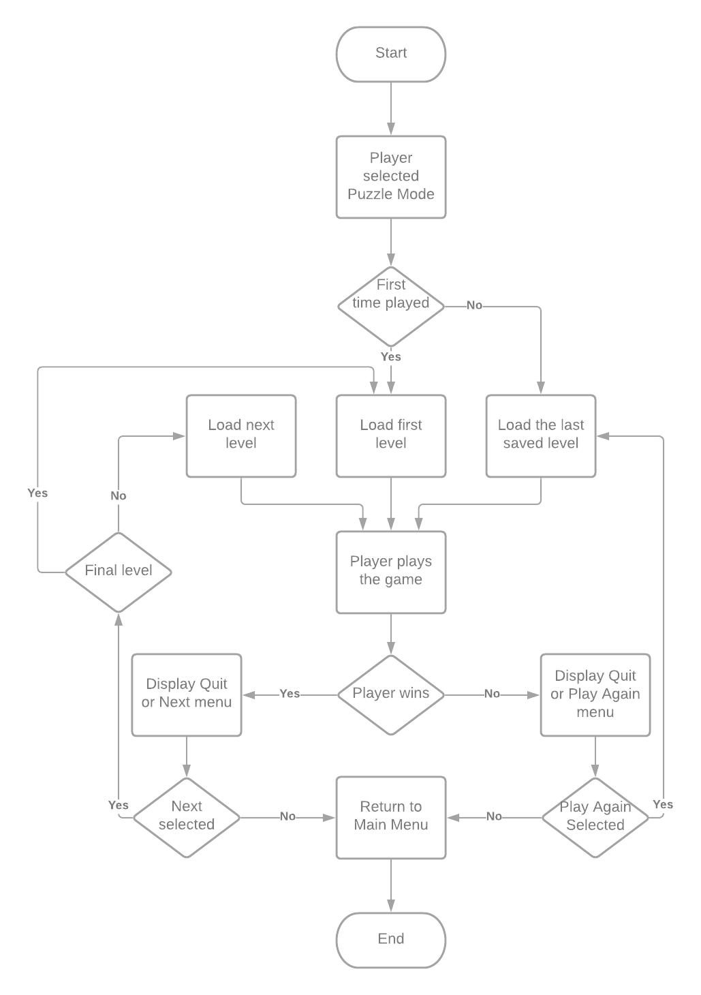

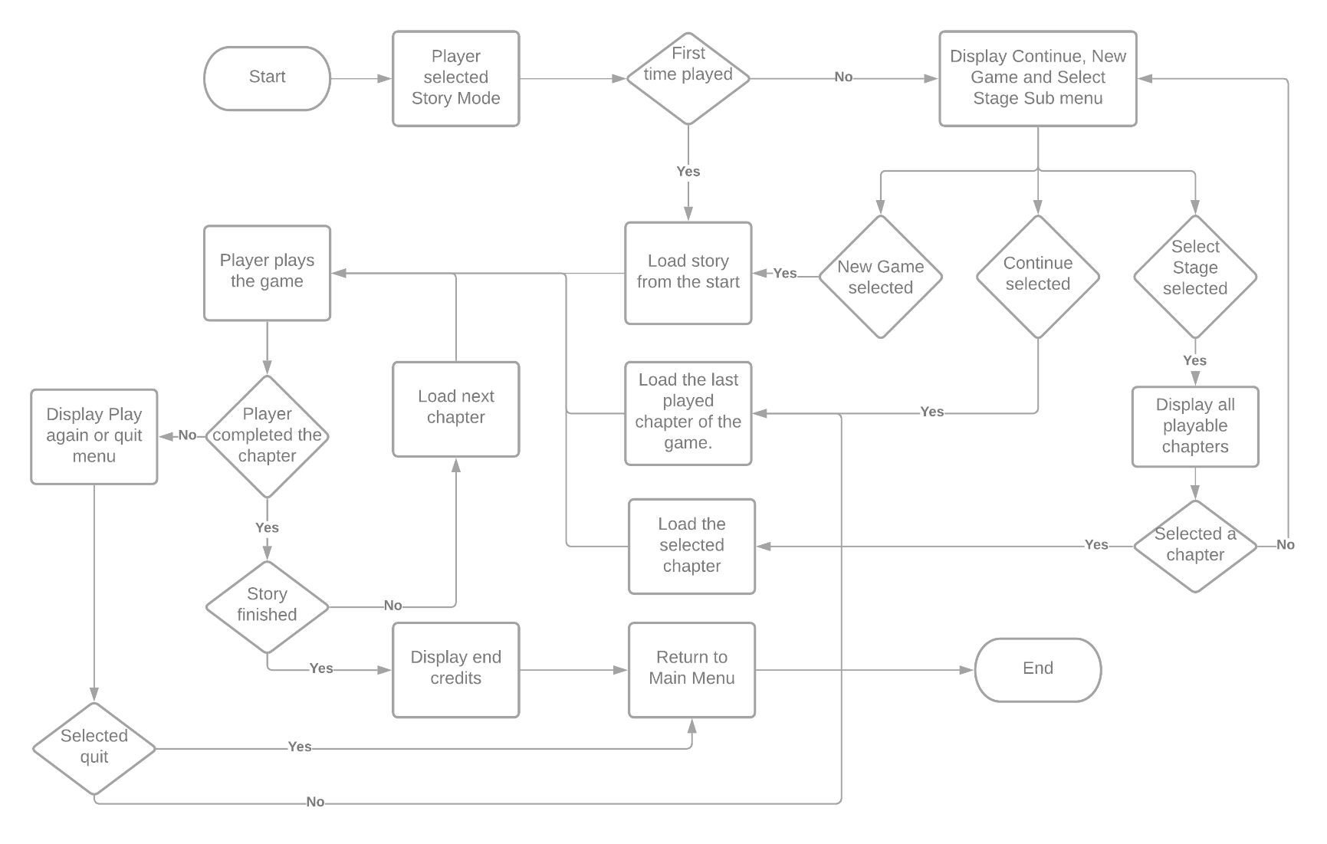

**Figure 4.3: Flowchart of the Propose System 2**

**Statistical Treatment of Data**

The following statistical methods were to be used to get an accurate and reliable interpretation of data.

**Statistical Treatment**

The researchers use this formula to get the average of the pupil’s performance on the test. The formula used in computing the average is:

**Average** = Summation of all scores obtained

Number of respondents

And also, the researchers use percentage analysis to obtain test scores in the survey. The percentage (P) is computed using the formula:

P=F/N*100

where:

F = frequency

N = total no. of respondents

The data gathered by the researchers were computed using the above stated statistical method to arrive on a reliable and valid interpretation of data.

**Chapter V**

**RESULTS & DISCUSSION**

This chapter deals with the presentation, analysis and interpretation of data on the effectiveness of the Dagohoy’s Revolt 3D Educational Game Application. The data were collected by distributing questionnaires to the respondents. These data were analyzed by using certain formulas and presented by using tables.

The table below shows the test performance of the Grade 6 pupils of Mater Dei Laboratory Elementary School without Dagohoy’s Revolt 3D Educational Game Application and with Dagohoy’s Revolt 3D Educational Game Application

Table 5.1 Test Performance of the Grade 6 pupils

|  |  |  |
| --- | --- | --- |
| **n=30** | | |
|  | **Without Dagohoy’s Revolt 3D Educational Game Application** | **With Dagohoy’s Revolt 3D Educational Game Application** |
|  | N=15 | N=15 |
| Highest Possible Score | 15 | 15 |
| Passing Score (60%) | 11 | 11 |
| Highest Score | 11 | 14 |
| Lowest Score | 2 | 9 |
| No. of Pupils Passed | 2 | 12 |
| No. of Pupils Passed (%) | 13.3% | 80% |
| No. of Pupils Failed | 13 | 3 |
| No. of Pupils Failed (%) | 86.7% | 20% |
|  |  |  |
| Average | 5.87 | 9.33 |

Without the use of Dagohoy’s Revolt 3D Educational Game Application, the highest score obtained was 11 and the lowest score gained was 2. Only 2 pupils got the passing score. The researchers based on the DepEd Order No. 8 Series of 2015 in which the passing percentage 60% is equivalent to 75 (transmuted). The group has an average score of 5.87.

On the other hand, with the Dagohoy’s Revolt 3D Educational Game Application, the highest score obtained was 14 and the lowest score gained was 9. The pupils who passed the test were 14. The group has an average score of 9.33.

The average scores of the pupils with the use of Dagohoy’s Revolt 3D Educational Game Application implied that it was effective on their test performance based from the results.

This signifies that the method used help the pupils to understand the Dagohoy’s Revolt.

**User-Guide**

Chapter five shows the screenshots of the system. In this chapter it will discuss what the screenshot is, and how the screenshot works. Chapter five also answers the objective of the project.

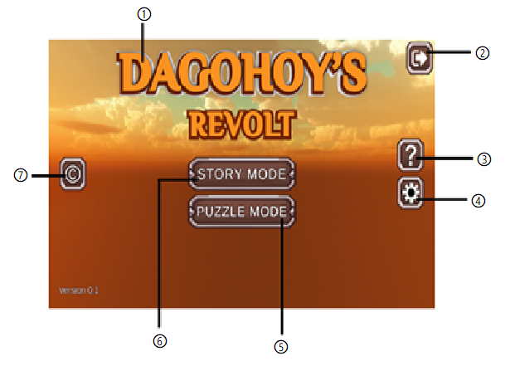

**Figure 5.1 : Main Menu**

Figure 5.1 shows the main menu interface of the game. The game has two modes, the story mode and puzzle mode. It follows how the parts work:

1. This displays the title of the game
2. This button exits the game
3. This button shows what the game is about
4. This button will display the settings
5. This button is for loading the puzzle mode of the game
6. This button is for loading the story mode of the game
7. This button will display the credits

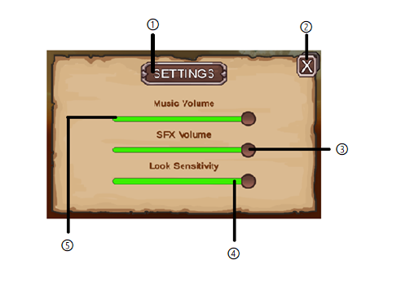

**Figure 5.2 : Settings**

Figure 5.2 shows the settings interface of the game where the players are can adjust the music volume, SFX volume, and the camera sensitivity of the game. It follows how the parts work:

1. This is the header of the panel
2. This button will close the settings panel
3. This slider will adjust the volume of sound effects
4. This slider will adjust the camera look sensitivity
5. 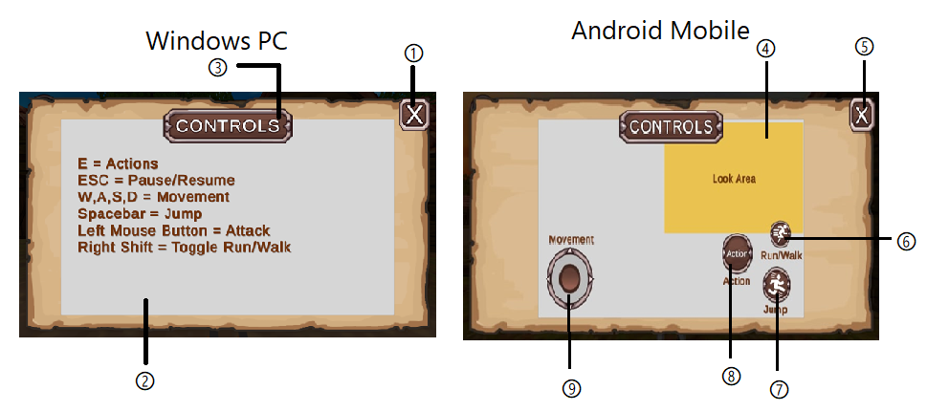This slider will adjust the volume of background music

**Figure 5.3 : Controls**

Figure 5.3 shows the controls interface where it displays how to navigate the game. It follows how the parts work:

1. This button will close the controls panel
2. This are the list of controls
3. This is the header of the panel
4. This is the look area of the game
5. This button will close the control panel
6. This button toggles the run or walk
7. This button is for jump
8. This button is the action button
9. 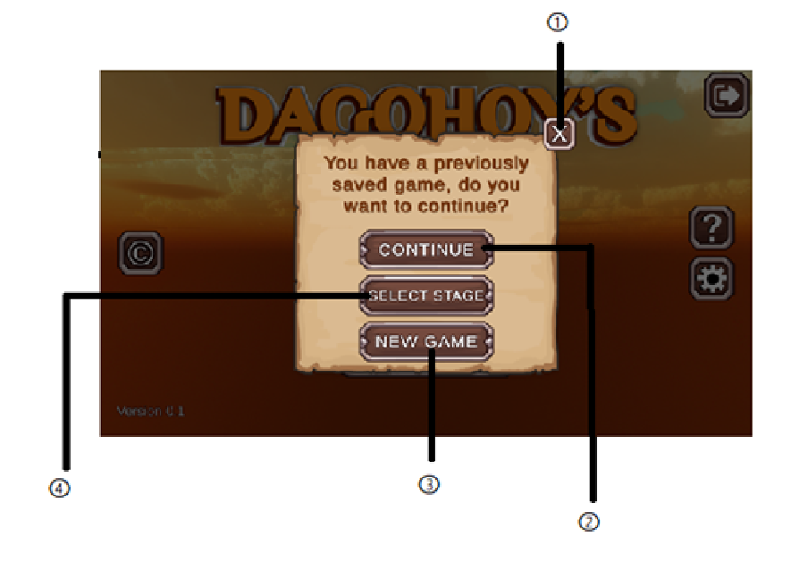This is the joystick for moving the character

**Figure 5.4 : Story Mode Menu 1**

Figure 5.4 shows the interface which display a pop-up menu that allow the player to choose continue, new game or select stage. This menu will appear if the player has already a progress on the story mode. It follows how the parts work:

1. This button will close the menu
2. This button is for continuing the progress of the game
3. This button is for loading a new game
4. This button is for displaying the playable stages of the game

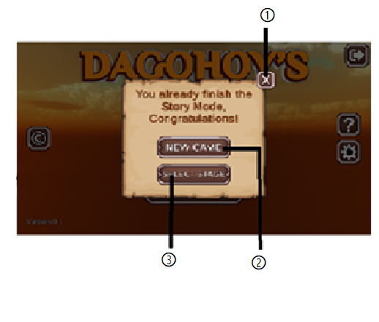

**Figure 5.5 : Story Mode Menu 2**

Figure 5.5 shows the interface which display a pop-up menu that allow the player to choose new game or select stage. This menu will appear if the player already finished the story mode. It follows how the parts work:

1. This button will close the menu
2. This button is for loading a new game
3. 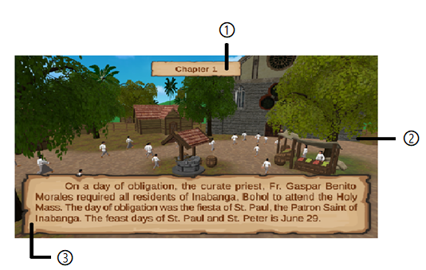This button is for displaying the playable stages of the game

**Figure 5.6 : Story Mode Cutscene**

Figure 5.6 shows the interface which display the cutscene of the story mode. It follows how the parts work:

1. This display the stage or progress of the game
2. This display the animation of the story
3. 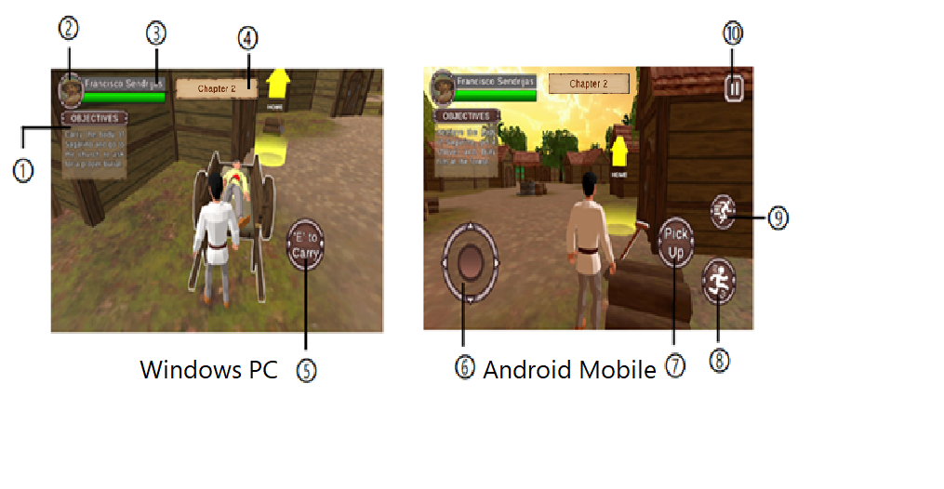This shows the dialogue of the story

**Figure 5.7 : Story Mode**

Figure 5.7 shows the interface of the game in story mode. It follows how the parts work:

1. This display the objectives of the game
2. This display the image of the character
3. This display the name of the character
4. This display the stage or progress of the story
5. This button is the action button
6. This is the joystick for moving the character
7. This button is the action button
8. This button is for jump
9. This button toggles the run or walk
10. This button exits the game

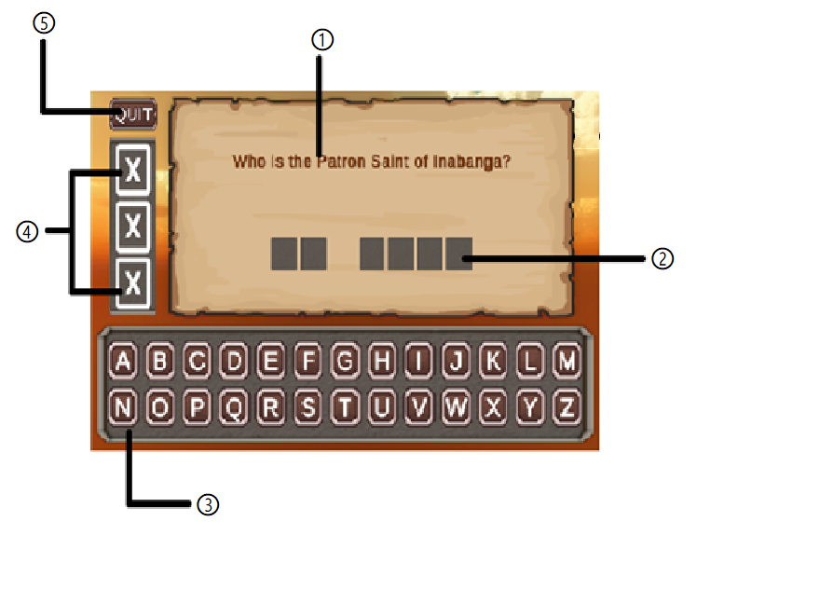

**Figure 5.8 : Puzzle Mode**

Figure 5.8 shows the interface which display the second mode of the game the puzzle mode. It follows how the parts work:

1. This display the questions of puzzle mode
2. This display the letter of the answer of puzzle mode
3. This shows the letters for the player to use to answer the puzzle mode
4. This shows how many wrong choices the player commits
5. 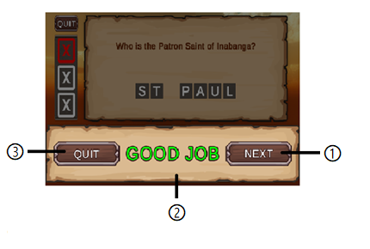This exit the puzzle mode

**Figure 5.9 : Puzzle Mode Menu**

Figure 5.9 shows the interface which display the pop-up menu after successfully answered the puzzle mode questions. It follows how the parts work:

1. This button will load the next question of the puzzle mode
2. 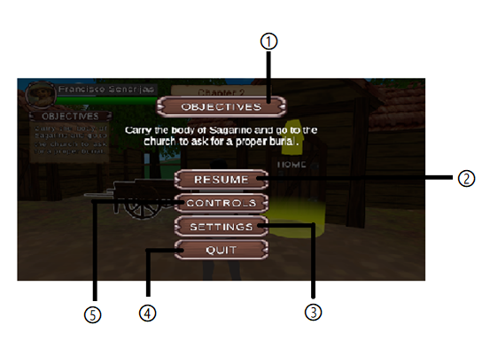This shows the motivational message of the puzzle mode
3. This button will exit the game

**Figure 5.10 : Pause Menu**

Figure 5.10 shows the interface which display the pause menu of the game. It follows how the parts work:

1. This is the header of the panel
2. This button resumes the game
3. This button will display the settings
4. This exits the pause menu
5. This button will display the controls

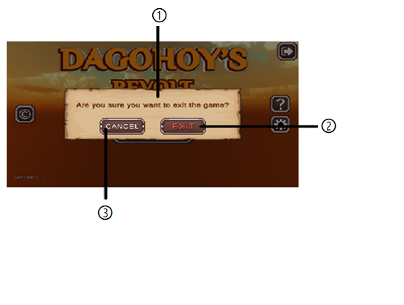

**Figure 5.11 : Exit Confirmation Menu**

Figure 5.11 shows the interface which display a confirmation menu for the player to choose before exiting the game. It follows how the parts work:

1. This display the confirmation message
2. This button exits the game
3. 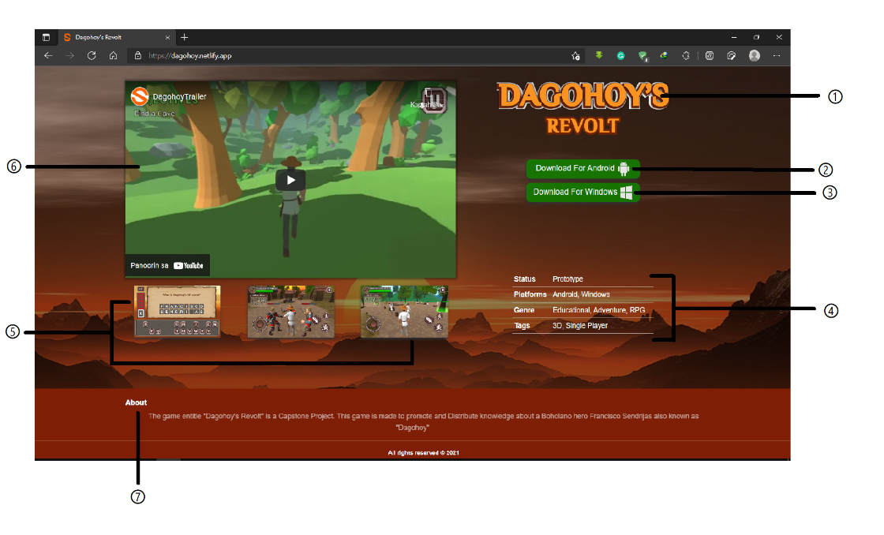This button cancels the exit of the game

**Figure 5.12 : Game Website**

Figure 5.12 shows the interface which display the game’s website where the player can download the game. It follows how the parts work:

1. This display the title of the game
2. This button displays the download button for android
3. This button displays the download button for windows
4. This display the status, platform, genre, and tags of the game
5. This display the screenshots of the game
6. This display the trailer of the game
7. This display the description of the game

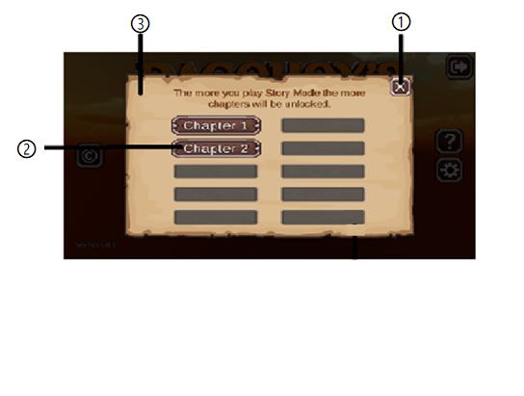

**Figure 5.13 : Select Stage**

Figure 5.13 shows the interface which display the playable stages of the game in story mode. It follows how the parts work:

1. This exits the select stage panel
2. This button is for loading the corresponding stage of the game
3. This shows the stages of the game

**Chapter VI**

**Summary, Conclusions and Recommendations**

This chapter indicates the summary, conclusions and recommendations of the researchers based on the data and information collected.

**Summary**

The study aimed to determine the effectiveness of Dagohoy’s Revolt 3D Educational Game Application in understanding and recognizing Dagohoy’s Revolt in Grade VI pupils of Mater Dei Laboratory Elementary School.

This study sought to answer the question, "Can this educational game be of help to pupils in learning Dagohoy’s Revolt?"

The researchers used experimental research to determine the result on the pupils who used the Dagohoy’s Revolt 3D Educational Game Application and to those who did not.

To obtain valid data supporting the proposed study, the researchers conducted a test to the two sections of Grade 6 pupils of Mater Dei Laboratory Elementary School and thirty (30) students were given same questionnaires where they asked questions regarding the history of Francisco Dagohoy’s Revolt. The researchers were able to play the application on the Grade 6 section 2 pupils of Mater Dei Laboratory Elementary School which consisted of fifteen (15) pupils. The conducted test results were analyzed and interpreted by the researchers.

**Conclusions**

This chapter presents the project conclusion, based on the researchers' findings, as well as recommendations that the researchers suggest that would improve the study.

On the findings of the study, there was significant difference between the performance of the pupils based on the test result. Gamification method (Dagohoy’s Revolt 3D Educational Game Application) was more effective compared to the Non-Gamification method in understanding the historical events of Dagohoy’s Revolt. 3D Educational Game Application is a potential strategy to be integrated in studying to provide desirable learning in developing story comprehension because pupils are more engaged in the game. Moreover, pupils were highly engaged when they visualized more pictures/images, motions as well as when they heard narrations and music making them easily comprehend the story.

**Recommendations**

The researchers came up to the following recommendations based on the above-mention conclusions and findings of the study:

Not only the application has its limitations, the researchers as well have their limitations in developing the system. Due to lack of resources, time and other development materials, the researchers hereby recommend the system to:

1. Have a wider accessibility for the application. Upload it to Google Play store or in other file sharing sites.
2. Ssfsd
3. Sdfsdf
4. sfsdf

For the study:

1. A larger sample size for the survey to make the supporting data more convincing.
2. Use the agile method in the system development to have much better outputs.

**USER’S GUIDE**

Installation

App installation is typically easy in android and windows pc where it needs to open or load the “.apk” file, and the android and windows system automatically installs the package into the system. To install Dagohoy’s Revolt on the phone, go to the website that the researchers provided, click the download button and load the “.apk” file.

To install Dagohoy’s Revolt on the Windows pc, go to the website that the researchers provided, click the download button. After downloading the file, double click to install and load the “.apk” file.

Getting Started

The game itself is straightforward. The game application was named "Dagohoy’s Revolt" because of its origin of the longest revolt in the Philippines, Dagohoy's Revolt. The player can choose from Story Mode, Quiz Mode, and Puzzle Mode, along with the joyful background music that makes the player enjoy their gaming experience.

Playing Dagohoy's Revolt

Choosing preferred “Game Mode”

When started, the game will display the menu screen where player can select Credits, About, and Settings to adjust the music volume, SFX volume, and look sensitivity.

The player is given a choice between three game modes, namely, "Story Mode," "Quiz Mode," and "Puzzle Mode."

**Story Game Mode**

This game mode gives the player an experience of what happened during the Revolts. The player has the chance to roam around the village, to the mountain and caves. The story mode includes objectives for the player. The player needs to finish every objective until the end in order to understand the story of the Dagohoy’s Revolt. The story mode also has a cut-scene where it will show up before the player starts to play. The cut-scene will explain the story further for the pupils to understand the history of the Dagohoy’s Revolt. This game mode will give an overview to the pupils about Dagohoy’s Revolt that happened during 1744.

Here is where the real action takes place. In this quiz game mode, the player will be given a set of questions to answer where they can choose the letter of their choice. To answer and get a perfect score, the player needs to start in Story Mode to understand and be able to get answers. In Story Mode, the players can find all answers Quiz Game Mode.

**Puzzle Game Mode**

Here is where the fun and challenging action takes place. In this puzzle game mode, the purpose of the game is simple—guess the answer. With a number of letters to pick from, players must guess the right ones without receiving three mistakes. Three mistakes led Francisco Dagohoy to be killed by the Spaniards. In Story Mode, the players can find all answers.

**APPENDICES**

****Transmittal Letter (Conduct for the study)

Republic of the Philippines

Mater Dei College

Tubigon, Bohol

October 6, 2021

**VIVIEN MASCARIÑAS**

Principal

MDC Laboratory Elementary School

Cabulijan, Tubigon, Bohol

Madam:

Greetings!

The undersigned students of the College of Arts, Sciences and Technology, Mater Dei

College, Tubigon, Bohol would like to conduct a study regarding our capstone entitled **“Dagohoy’s Revolt: A 3D Educational game for Elementary Pupils”** in partial fulfillment of the requirement of Experimental Research.

In relation with this, the researchers would like to request permission from your office to allow us to conduct our study to the Grade VI pupils of your school in their Araling Panlipunan subject on November 9.

Your favorable action on this request is highly appreciated. Thank you so much.

Respectfully yours,

**LORD SON V. PABRIGA (sgd.)**

Group Leader

Endorsed by: Noted by:

**BENJIE B. LENTERIA (sgd.)** **JOSEFINA J. PANGAN** **(sgd.)**

Capstone Project Adviser College of Arts, Sciences & Technology, Dean

Approved by:

**VIVIEN MASCARIÑAS (sgd.)**

Principal

**APPENDIX B**

**QUESTIONNAIRE**

DIRECTIONS: Read and analyze the following questions. Write the letter of your answer.

1. The priest who commanded Francisco Dagohoy’s brother to find the traitor to arrest Ibong.

* Fr. Gaspar Benito Morales
* Fr. Juan Bautista Medice
* Fr. Pedro de Santa Barbara
* Fr. Lambertini S.J.

1. The last name of Francisco.

* Gaspar
* Dagohoy
* Sendrijas
* Barbara

1. When did the Dagohoy’s Revolt started?

* 1750
* 1744
* 1780
* 1777

1. Who killed Francisco Dagohoy’s brother, Sagarino?

* Fr. Morales
* Francisco Dagohoy
* Mayor Don Jose Cairo
* Ibong

1. When did Dagohoy’s Revolt ended?

* 1880
* 1829
* 1840
* 1890

1. What does Dagohoy means?

* Dagon sa Huyuhoy
* Dagon sa Kahoy
* Dagon sa Huyhuy
* Dagon sa Agohoy

1. From what town of Bohol Francisco Dagohoy lived?

* Tubigon
* Talibon
* Inabanga
* Clarin

1. Who killed Sagarino?
2. Francisco Dagohoy
3. Fr. Lambertini
4. The Mayor of Cebu
5. Ibong
6. Who is the brother of Francisco Dagohoy?

* Sagarino
* Ibong
* Pablo
* Dante

1. What is the reason of Francisco Dagohoy’s Revolt?

* Injustice and Lack of Charity
* Violent
* Unfaithful
* Incompetence

1. Francisco Dagohoy went on hiding and where did he hide?

* Mountain
* Forest
* Sea
* Cave

1. Who is the expert in Guirilla Warfare?

* Sagarino
* Ibong
* Francisco Dagohoy
* Fr. Morales

1. What is the longest revolt in Philippine History?

* Revolt of Sagarino
* Fr. Lambertini's Revolution
* Revolt of the Revolution
* Dagohoy's Revolt

1. Who did not attend the Holy Mass?

* Fr. Lambertini
* Francisco
* Ibong
* Sagarino

1. How long does the revolt happen?

* 75 years 85 years
* 80 years 100 years

**The Dagohoy Revolution: The Longest Revolution in Philippine History 1744-1829 (85 Years).**

Francisco Dagohoy: Champion of Filipino Freedom. In the year 1744, the church priest of Inabanga (Bohol) refused to provide permission for the catholic funeral of a Boholano who died in a fight. Francisco "Dagohoy" Sendrijas, the brother of the victim, misunderstood this decision following the Church's Laws. Francisco Sendrijas finally killed the priest, taking it for a personal attack. Dagohoy became a wanted man after that. As a result, he escaped. The injustice and lack of charity of the Priest Gaspar Benito Morales, S.J., priest of Inabanga, who had a violent character, have been the reasons for Dagohoy's revolt.

**CHAPTER 1**

The parish priest, Fr. Gaspar Benito Morales, commanded the residents of Inabanga, Bohol, to attend the Holy Mass on a day of honor. The Patron Saint of Inabanga is St. Paul. St. Paul and St. Peter have same festival day which is June 29. Fr. Morales noticed that one person was missing or did not attend the required Holy Mass. Teresita Roble named the person “Ibong.” Fr. Morales described Ibong as an unbeliever.

**CHAPTER 2**

Ibong was known as a brave man of Talibon, a town near Inabanga. Ibong traveled the mountains after abandoning his Catholic faith. On the other hand, no one tried to follow Fr. Morales's order. The next day, Fr. Morales ordered to arrest Ibong. Sagarino was Francisco's older brother and a town police officer, decided to travel to the mountain. Sagarino caught Ibong, but he refused to be arrested. Police officer Sagarino was killed in the fight, and Ibong escaped.

**CHAPTER 3**

A runner was sent to Inabanga to tell Francisco about his brother's death. In the afternoon of June 30, Francisco was prepared to meet the group carrying Sagarino's body towards Inabanga. In the evening, the group arrived in Inabanga but Fr. Morales refused to be disturbed for the night. Francisco Dagohoy was desperate to revenge the murderer and went out to the mountain but could not find the killer.

**CHAPTER 4**

The next day, July 1, Francisco carried Sagarino's body to the church for

blessing and proper burial. Since Sagarino died in a battle, Fr. Morales asked for a funeral fee of two (2) pesos from Francisco. Francisco begged for an exemption because the death was caused by Fr. Morales’s order to arrest Ibong. The priest refused his burial in the catholic cemetery, saying that he died due to his participation in a fight which was a major embarrassment. Francisco replied that his brother did not plan to murder Ibong, the unbeliever, but to arrest him following the priest's command and because of it Sagarino died.

**CHAPTER 5**

Francisco "Dagohoy" Sendrijas refused to pay the required funeral fee. Francisco left Sagarino's body at the church, and it hasn't been buried after three (3) days. And Fr. Morales didn’t care of burying it. The dead body was slowly decomposed and eaten by worms, releasing a terrible smell all over the town. In the end, Francisco buried his brother without the benefit of a Catholic burial. As a result of these happenings, Francisco Sendrijas promised to correct the injustice done to his brother. In the process, he stopped paying offerings to the Spaniards and refused to provide the required "forced" work. The angry Francisco gathered all his family, friends, and followers, telling them of the sad realities, and promised to follow his decision to take revenge. Dagohoy and his followers continue in their revolt for 85 years, the longest revolt in the Philippines.

**CHAPTER 6**

Dagohoy promised that he would wait to the day to make sure Fr. Morales's body would decompose and got eaten by the worms. With such determination, he went into hiding in the mountains, followed by over 3,000 people of both genders, utilizing for their food from the large hacienda of the priest. With Fr. Morales's strict attention, the rebels' plan were made hard to be successful. However, they were satisfied in causing him great madness by killing Fr. Lambertini, the parish priest of Jagna.

The Mayor of Cebu went to Bohol to punish the rebels. The Mayor threatened to hang the town's leaders if they would not give up the man who killed the church priest. The leaders went to convince Francisco to surrender so they would be saved from the danger involved and being killed by the army that the military government would send to revenge. Francisco Dagohoy and his followers refused to surrender but continued their guarded freedom for almost a century.

**CHAPTER 7**

The revolt in Bohol between the 7th and 18th centuries had reached a stage of creating a crowd of rebels, waving their flag of revolution and unrest. The majority of the people's obedience and loyalty to the government was weakened due to the revolution, which harmed the strength of the Catholic faith. As a result, those who went in hiding in the mountain separated themselves from the eight churches then existed and went back to the customs of Hinduism. There have been minor changes in Bohol for the past

years. They were little enough not to deserve as much attention as the shocking revolt at the beginning of 1744. The lives of the Jesuit Fathers Lambertini and Morales were claimed in a horrible killing.

What is certain is that more than 3,000 Boholanos joined army under the leadership of Francisco Sendrijas. Francisco was a sad man whose situation was deserving of kindness and understanding but later became the murderer of the sinful killing of the Catholic Priests. Francisco Dagohoy was an expert in Rebel combat. And very familiar with caves. The people say that Francisco is good at disappearing in towns. The Cave near the village of Danao was the headquarters of Francisco. One of the many crystal-studded passages inside Dagohoy's Cave has an underwater path all the way to dry ground. Every time Spaniards would search the Cave, Dagohoy would dive underwater using this passage to stay hidden in the breathing space. It is unknown how Francisco Dagohoy died. He probably died of old age or sickness a little before or after the 19th century. What is certain is that, the revolution did not end with his death.

The cries for help by the people of the towns increased more and more. After being informed of the state of unrest in Bohol and taking temporary measures, the new Mayor of Cebu, Don Jose Cairo, increased awareness of the failings of the actions made by his administration's order. Therefore, he decided to join the people of Cebu, who were skilled in using guns. Finally, full of incredible passion, the Mayor himself volunteered to led the mission. He was determined to restore the peace and safety of Bohol.

The name Dagohoy connects the Bisayan phrase, Dagon sa huyuhoy, or talisman of the breeze in English. Francisco "Dagohoy" Sendrijas will always live in the pages of Philippine history, not only as a good brother and a heroic man but also as a leader of the longest Filipino rebellion on record. His revolt lasted 85 years. The Dagohoy rebellion features in the Bohol provincial flag as one of the two bolos or local swords with handles and hand-guards on top. These two bolos, leaning respectively towards the left and right, represent the Dagohoy and Tamblot revolts, symbolizing that "a true Boholano will rise and fight if external factors involve them into something beyond reason or tolerance." Vice President Carlos P. Garcia proposed the town name "Dagohoy" in honor of the greatest Boholano hero, Francisco Sendrijas alia s Dagohoy.

**SAMPLE CODE**

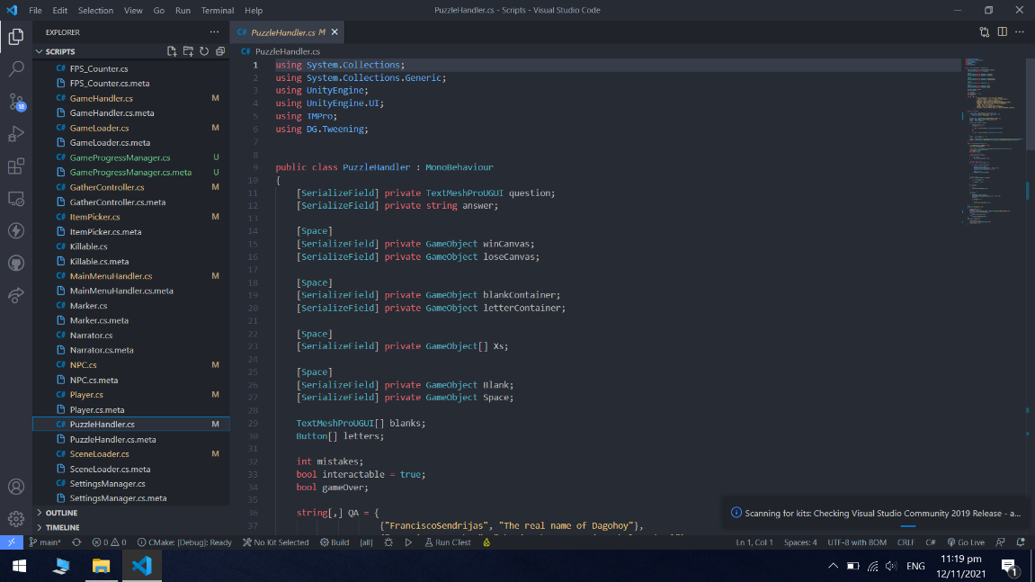

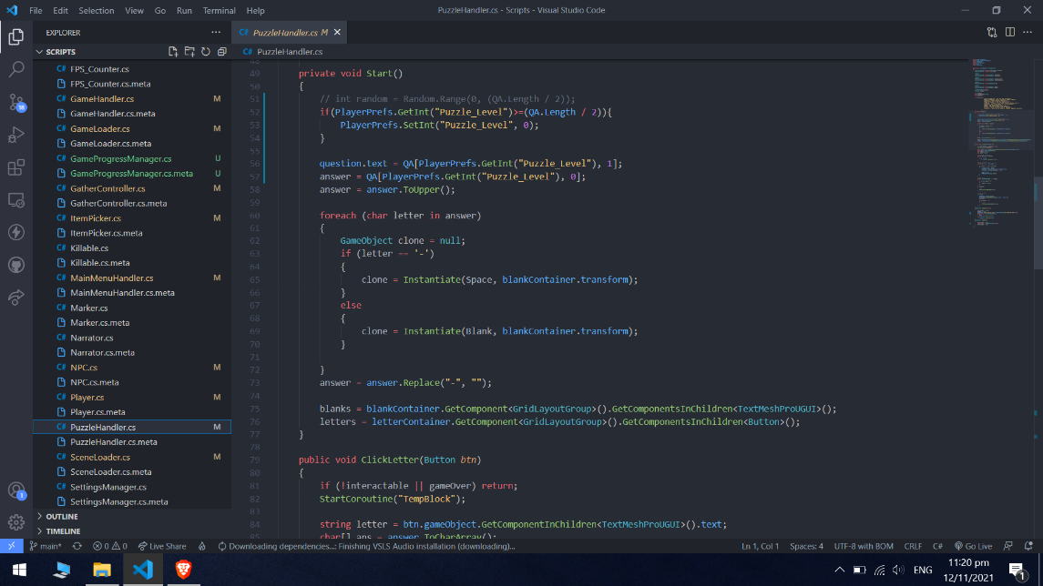

**PICTURE DOCUMENTATION**

* **RESEARCHERS WHILE DEVELOPING THE GAME**

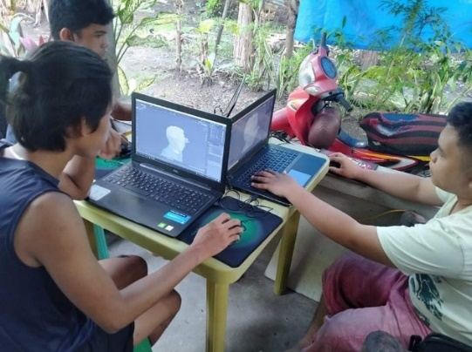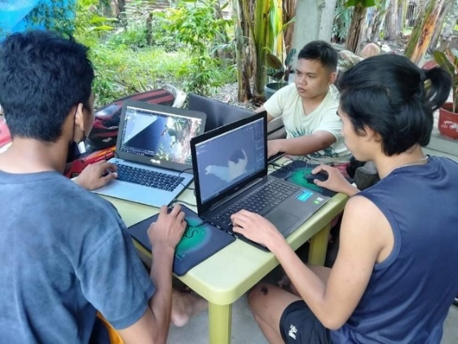

* 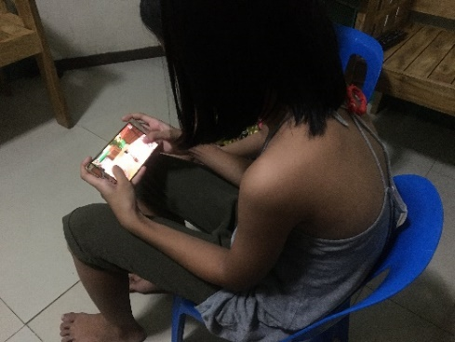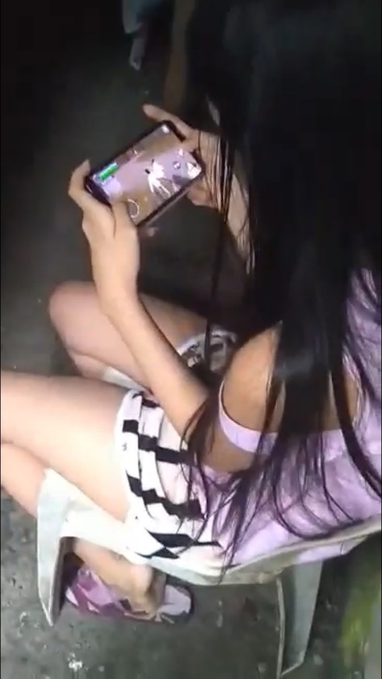**SOME OF THE GRADE 6 SECTION 2 PUPILS WHO PLAYED THE DAGOHOY’S REVOLT 3D APPLICATION**

**CURRICULUM VITAE**



**LORD SON V. PABRIGA**

Pinayagan Norte, Tubigon, Bohol

09673428754

[Zanders.lsp@gmail.com](mailto:Zanders.lsp@gmail.com)

**PERSONAL DATA:**

Birthday: October 28, 1999

Age: 22 years old

Nationality: Filipino

Gender: Male

Civil Status: Single

**EDUCATION**:

2020 – Present Mater Dei College

Cabulijan, Tubigon Bohol

2018 – 2020 STI College – Bohol

Bachelor of Science in Information Technology

2013 – 2018 Holy Cross Academy

Pooc Oriental, Tubigon, Bohol

2010 – 2013 Pinayagan Norte Elementary School

Pinayagan Norte, Tubigon, Bohol

**SKILLS**

* Technology Skills: Programming, Photo editing, video editing, 3D Modeling, Computer Literate, ability to identify and solve hardware and software problems

Knowledgeable in following:

* Microsoft Office Application
* Blender
* Unity
* Arduino
* Language Skills: English, Tagalog, Bisaya
* Personal Skills: Fast Learner, can independently work alone



**R.A. PATRICIA C. CORAGE**

Guiwanon, Tubigon, Bohol

09395177799

[Raptrca@gmail.com](mailto:Raptrca@gmail.com)

**PERSONAL DATA:**

Birthday: November 19, 1999

Age: 22 years old

Nationality: Filipino

Gender: Female

Civil Status: Single

**EDUCATION**:

2020 – Present Mater Dei College

Cabulijan, Tubigon Bohol

Bachelor of Science in Information Technology

2018 – 2020 STI College – Bohol

Bachelor of Science in Information Technology

2013 – 2018 Holy Cross Academy

Pooc Oriental, Tubigon, Bohol

2007 – 2013 Guiwanon Elementary School

Guiwanon, Tubigon, Bohol

**SKILLS**

* Technology Skills: Computer Literate, photo editing, video editing, graphic designing, vlogging,

Knowledgeable in following:

* Microsoft Office Application
* Adobe Software Application
* Language Skills: English, Tagalog, Bisaya, Ilonggo
* Personal Skills: Can work under pressure, can independently work alone and with workers, can flexibility handle different tasks & projects



**GLENN GERALD F. DAPITILLA**

Guiwanon, Tubigon, Bohol

09563216992

[glenzkie44@gmail.com](mailto:glenzkie44@gmail.com)

**PERSONAL DATA:**

Birthday: February 02, 2000

Age: 21 years old

Nationality: Filipino

Gender: Male

Civil Status: Single

**EDUCATION**:

2020 – Present Mater Dei College

Cabulijan, Tubigon Bohol

Bachelor of Science in Information Technology

2018 – 2020 STI College – Bohol

Bachelor of Science in Information Technology

2013 – 2018 Holy Cross Academy

Pooc Oriental, Tubigon, Bohol

2007 – 2013 Calape Central Elementary

Sta. Cruz, Calape, Bohol

**SKILLS**

* Technology Skills: Computer Literate, photo editing, video editing

Knowledgeable in following:

* Microsoft Office Application
* Blender
* Unity
* Language Skills: English, Tagalog, Bisaya
* Personal Skills: Can help on tasks/work, can independently work with workers



**MELCHIZEDEK A. CRUEL**

Pinayagan Sur, Tubigon, Bohol

09075272457

[melkocruel@gmail.com](mailto:melkocruel@gmail.com)

**PERSONAL DATA:**

Birthday: October 19, 1999

Age: 22 years old

Nationality: Filipino

Gender: Male

Civil Status: Single

**EDUCATION**:

2020 – Present Mater Dei College

Cabulijan, Tubigon Bohol

Bachelor of Science in Information Technology

2013 – 2018 Holy Cross Academy

Pooc Oriental, Tubigon, Bohol

2007 – 2013 Pinayagan Sur, Elementary School

Pinayagan Sur, Tubigon, Bohol

**SKILLS**

* Technology Skills: Computer Literate, photo editing, video editing

Knowledgeable in following:

* Microsoft Office Application
* Blender
* Unity
* Language Skills: English, Tagalog, Bisaya
* Personal Skills: Fast Learner, can independently work with workers



**BRYLE ANTHONY M. OREVILLO**

Pooc Occidental, Tubigon, Bohol

09618166545

[navi.brylee2@gmail.com](mailto:navi.brylee2@gmail.com)

**PERSONAL DATA:**

Birthday: August 1, 1999

Age: 22 years old

Nationality: Filipino

Gender: Male

Civil Status: Single

**EDUCATION**:

2018 – Present Mater Dei College

Cabulijan, Tubigon Bohol

Bachelor of Science in Information Technology

2018 – 2020 STI College – Bohol

Bachelor of Science in Information Technology

2013 – 2018 Holy Cross Academy

Pooc Oriental, Tubigon, Bohol

2007 – 2013 Mater Dei College - Laboratory Elementary School

Cabulijan, Tubigon, Bohol

**SKILLS**

* Technology Skills: Programming, 3D editing, video editing

Knowledgeable in following:

* Blender
* Unity
* Language Skills: English, Tagalog, Bisaya
* Personal Skills: Fast Learner, can work on-time

**REFERENCES**

3D Printers Improve Student Education Online And In the Classroom. (2016, March 14). UTA Online. Retrieved from <https://academicpartnerships.uta.edu/articles/education/how-can-3d-printers-be-used-for-educational-purposes.aspx>.

Abakada - Tagalog Alphabet - Apps on Google Play. Retrieved from <https://play.google.com/store/apps/details?id=co.familyplay.abakada&hl=en_US&gl=US>

Briones, J. (2015, July 21). Methodology It Capstone Projet. Methodology it capstone projet. Retrieved from <https://www.slideshare.net/jun1brio/methodology-it-capstone-projet>.

D. (n.d.). SEED | Digital Future Lab. SEED | Digital Future Lab. Retrieved from <http://digitalfuturelab.com/seed-2-2/>.

De Guzman, N. (2019, August 27). Unsung Heroes From Regional Parts Of the Philippines. Retrieved from Esquiremag.ph. <https://www.esquiremag.ph/long-reads/features/unsung-regional-heroes-who-deserve-recognition-a1729-20190827-lfrm2>.

Fadel, C. (2017, December 12). We Need To Modernize Education. The Clock Is Ticking (Opinion). Education Week. Retrieved from <https://www.edweek.org/teaching-learning/opinion-we-need-to-modernize-education-the-clock-is-ticking/2017/12>.

Francisco Dagohoy Day: Legacies Of Dagohoy (Last Of a Series). (2021, July 5). BOHOLCHRONICLE.COM.PH. Retrieved from <https://www.boholchronicle.com.ph/2021/07/06/francisco-dagohoy-day-legacies-of-dagohoy-last-of-a-series/>.

Gouveia, D. (2001, May 1). Game Development With Unity. Game Development with Unity. Retrieved from <https://www.slideshare.net/davidluzgouveia/game-development-with-unity>.

Joel, D. (2017, August 17). Four Reasons Why You Should Study History | This.. this.. Retrieved from <https://this.deakin.edu.au/study/four-reasons-why-you-should-study-history>.

Luengo, R. S. (1991). A History of the Philippines: A focus on the Christianization of Bohol (1521-1991) (NaN ed.). Mater Publications.

M., A. (2013, June 19). Diagrams In Game Development. Vanilla Code Snips. Retrieved from <https://vanillacodesnips.wordpress.com/2013/06/19/diagrams-in-game-development/>.

McKnight , D. (2014, January 14). Computertots®. | Technology Education Trends for July 2012. Computertots®.. Retrieved from <https://www.computertots.com.my/index.php?cur=news/view&id=4&title=Technology_Education_Trends_for_July_2012>

N. (2021, January 28). Software Development Life Cycle Series: The Waterfall Model - Retrieved from <https://niarcas.com/software-development-life-cycle-series-the-waterfall-model/>.

Saini, A. (2018, January 30). How To Create a Production Plan Concept - Important Phases To Consider -. How to create a production plan concept - Important Phases to consider -. Retrieved from <https://www.ommzi.com/create-production-plan-concept-important-phases-consider/>.

Shung, B. (2012, October 14). Educational Apps For Android And IOS – Maddie And Matt. HowToQuick.Net. Retrieved from <https://www.howtoquick.net/2012/10/educational-apps-for-android-and-ios-maddie-and-matt.html>.

Tirol, J. (2021, June 29). Francisco Dagohoy Day (Part 2). BOHOLCHRONICLE.COM.PH. Retrieved from <https://www.boholchronicle.com.ph/2021/06/30/francisco-dagohoy-day-part-2/>.

Tirol, J. (2021, July 5). Francisco Dagohoy Day: Legacies Of Dagohoy (Last Of a Series). BOHOLCHRONICLE.COM.PH. Retrieved from <https://www.boholchronicle.com.ph/2021/07/06/francisco-dagohoy-day-legacies-of-dagohoy-last-of-a-series/>.

Tagalog Toddler Games for Kids - Apps On Google Play. (n.d.). Tagalog Toddler Games for Kids - Apps on Google Play. Retrieved from <https://play.google.com/store/apps/details?id=co.familyplay.tagalogtoddler&hl=en_US&gl=US>.

VanBaren, J. (2019, January 22). What Are the Types Of Action Research Design? | Bizfluent. Bizfluent. Retrieved from <https://bizfluent.com/list-7608678-types-action-research-design.html>.

.